Formal Methods (SE2003)
Date: 18th March 2025
Course Instructor(s)
Dr.Wafa Basit
Sessional-I Exam
Total Time: 1 Hours
Total Marks:30
Total Questions: 1
Semester: SP-2025
Campus: Lahore
Dept: Software Engineering

____________________________ _______ _______ _____________________
Student Name Roll No Section Student Signature

____________________________ _____________________
Vetted by Vetter Signature

Instructions
- Make assumptions where necessary
- In case of multiple solutions, mention the final one
- All Questions have to be attempted on question paper.
- Please draw neat and understandable diagrams
- Use of lead pencil is not allowed.
Question # 1 We wish to build a temperature sensor as part of some larger piece of equipment. We might encapsulate the recording of the temperature in the following Fahrenheit abstract data type. Fahrenheit temperatures range from absolute zero up to a maximum temperature of 5000_F. Since absolute zero is −459.4⁰ F:

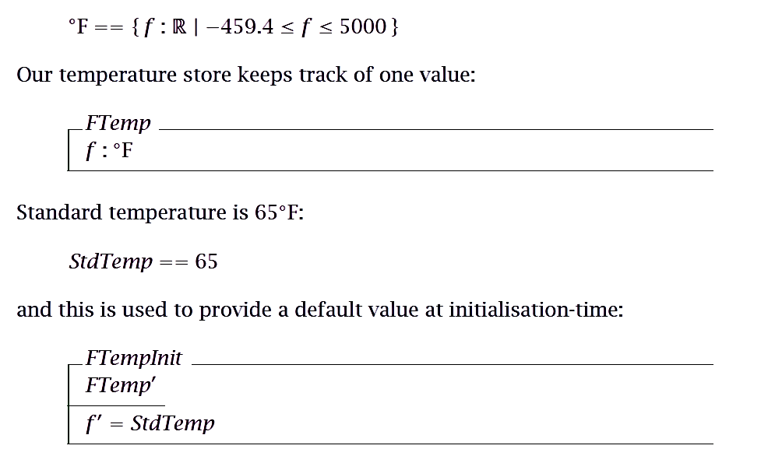

- The temperature can always be incremented, provided that the value does not
go above the maximum: (5 Points)
FTInc

- Similarly, the temperature can always be decremented, provided that the value
does not go below the minimum: (5 Points)
FTDec

At the design stage, the internal representation need not be kept in Fahrenheit: it could easily be maintained in Celsius. Celsius values are those above absolute zero, which is −273_C. For convenience, we choose a maximum value of 2760⁰C.
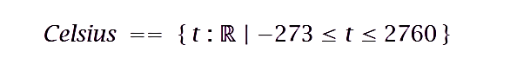
The formula to convert Celsius to Fahrenheit can be defined as:
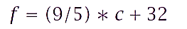

- Write down a ConvertFC operation schema which takes Fahrenheit as input and converts it into Celsius. Make sure that input and output are both within the defined limits.
ConvertFC

- Write down a ConvertCF operation schema which takes Celsius as input and converts it into Fahrenheit. Make sure that input and output are both within the defined limits. (5 Points)
ConvertCF

- Write down an Out of Range error schema that outputs an error message if the input Celsius temperature is out of range. (5 Points)
Error

- Draw a petrinet to model the scenarios in part 4 and 5. (5 Points)

-------Good Luck-----

